**DBMS Laboratory**

**UE19CS304**

**5th Semester, Academic Year 2021-22**

Week #: 4 - Constraints and Views Date: 26/9/2021

|  |  |  |
| --- | --- | --- |
| Name :  SUMUKH RAJU BHAT | SRN :  PES1UG19CS519 | Section :  H |

1. Constraints:

- Creating and using a db called db519

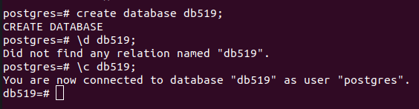

- Create employee table called employee519. Set primary key, not null and check constrainsts as specified



- Create department table called department519. Set primary key and unique constraints as specified.

Screenshot from 2021-09-26 11-53-41

- Create dept_locations table called dept_locations519. Set primary keys.

Screenshot from 2021-09-26 11-54-30

- Create projects table called project519. Set primary keys, default value.



- Create works_on table called works_on519. Set primary keys.



- Create dependents table called dependents519. Set primary keys, check constraint, default value and not null constraint as specified.



- Set foreign keys in all the tables using alter command:









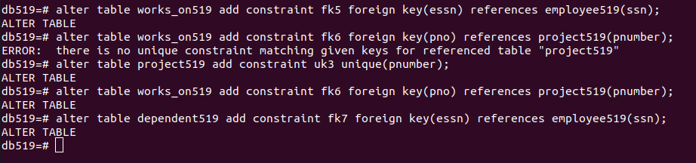

- Resultant schemas after all the mentioned commands:

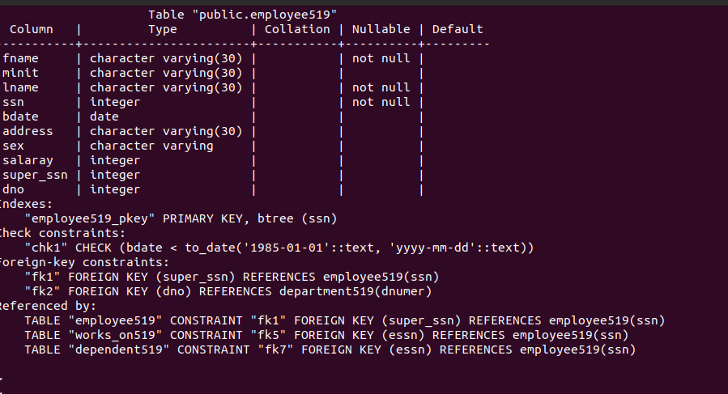

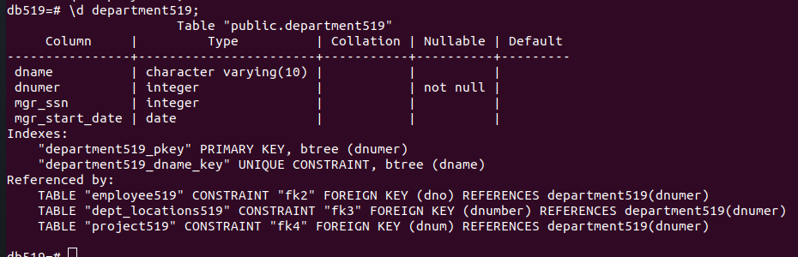

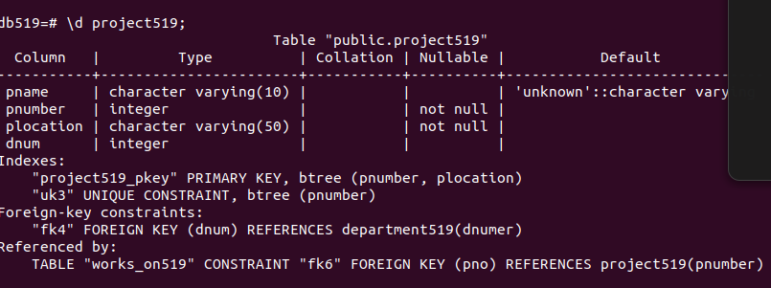

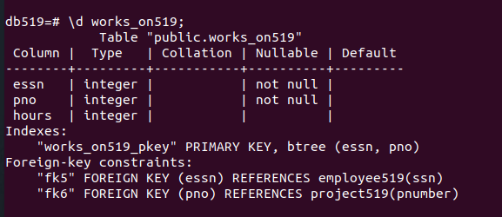

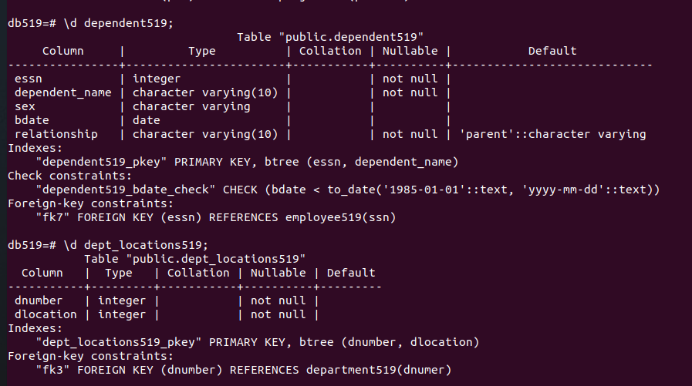

1. (b) Views:

- Insert some values into the department519 table to showcase view commands

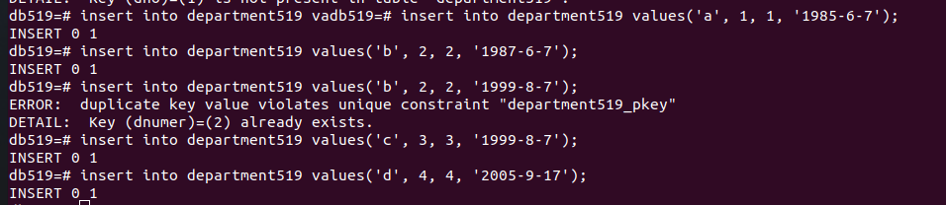

- Create 2 views new_mgrs and old_mgrs based on mgr_start_date with a threshold of 1990 using create view command. The resultant view is also shown using select command. Finally they are dropped using drop view command.

Screenshot from 2021-09-26 12-23-21

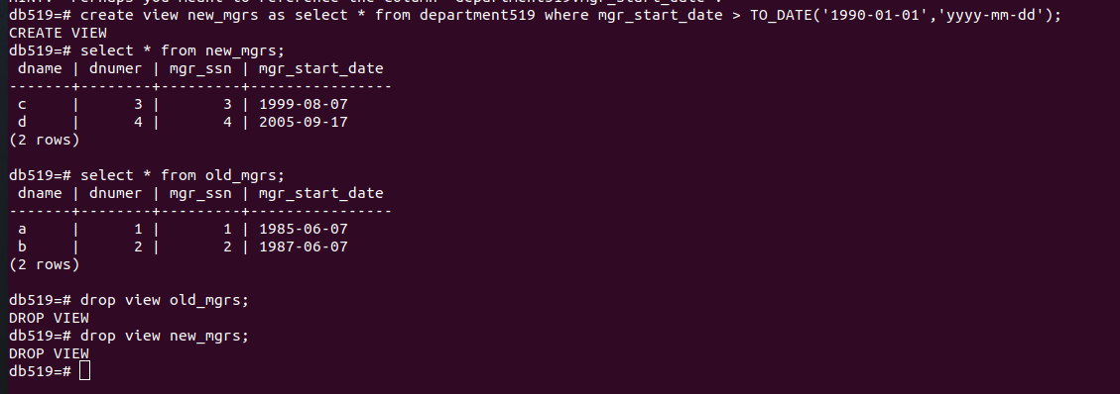

c) (2.c.) Create users, grant and revoke previliges

- Create users

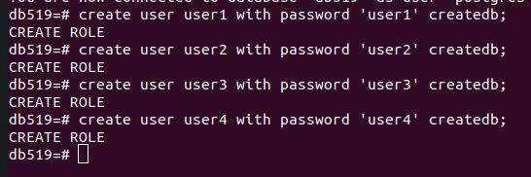

1. Grant select previliges to user1 on employee table

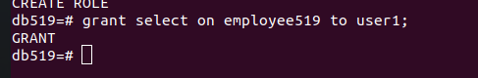

Verification:

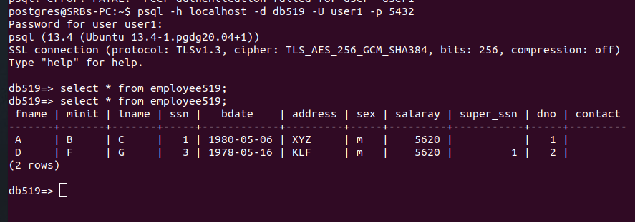

1. Grant insert previliges on department table to user2

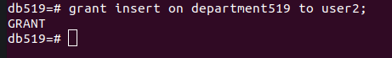

Verification:

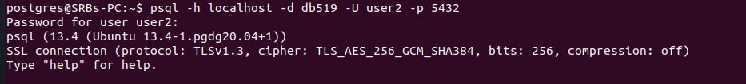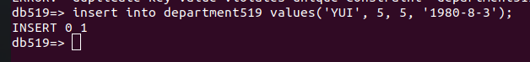

1. Grant all previliges to user3 on all tables

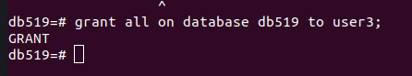

OR

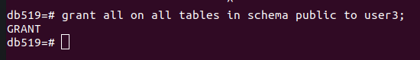

Verification:

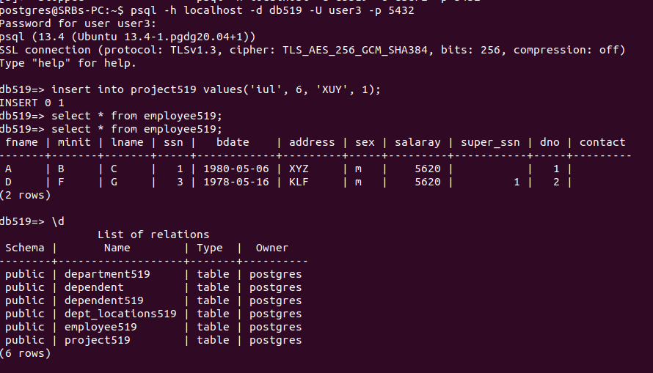



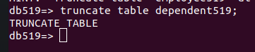

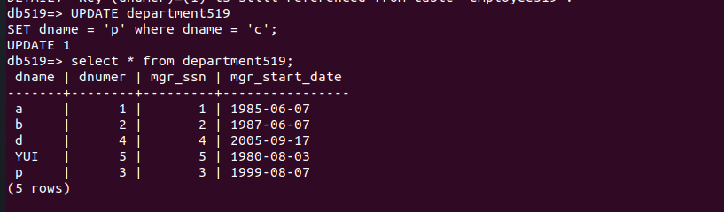

1. Grant insert, delete, update previliges on project and dependent table to user4

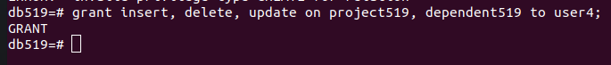

NOTE: to use the where clause for deleting specific records and updating specific records, we need to provide previlige of select command as well.

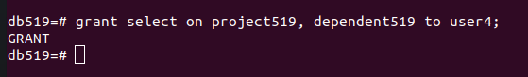

Verification:

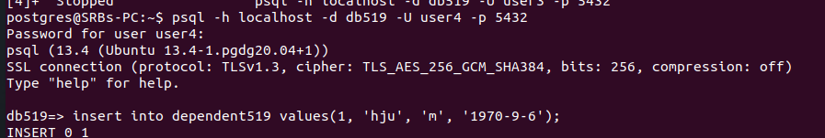

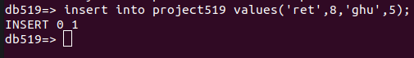

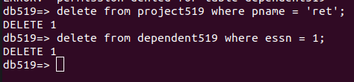



Screenshot from 2021-09-26 17-56-56

d) (2.d.)Add and drop columns using alter command

- Add new column contact in employee and duration in project. For the purpose of showcasing drop column, columns X and Y are newly added and dropped. The effect is also shown. The schema has no X and Y after dropping which is initially added.

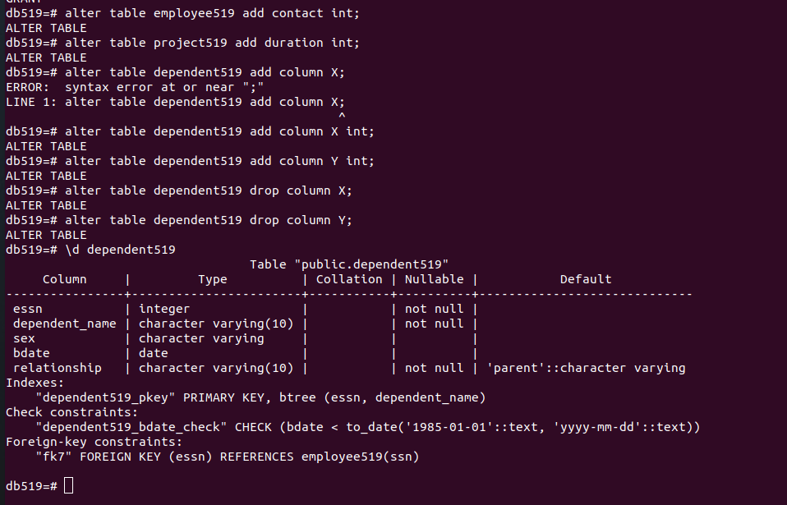

1. (2.a.) Drop and truncate tables

- Drop works_on table. We can see that the schema is not present after dropping. As drop deletes all the entries and also the schema.

Screenshot from 2021-09-26 13-33-42

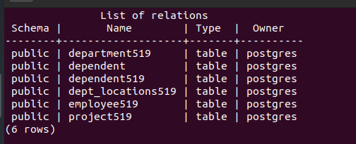

- Truncate dependents table. Even after truncating, the schema is present because truncate deletes only the entries and keeps the schema.

